Points of Interest on the Mauna Loa Road
Bold numbers are miles measured from MLO going downhill.
Numbers in (parenthesis) denote travel up the mountain with mileage beginning at the Saddle Road cut-off.
DOWN (UP)
0 (17.6) NOAA Mauna Loa Atmospheric Observatory at the 11,140 ft elevation of Mauna Loa Volcano is the site for measurements of CO2, CO, CH4, CFC's, ozone, solar radiation, atmospheric dust, stratospheric aerosols and temperatures, and many other measurements.
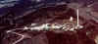
0.3 (17.3) Beginning of the hiking trail to the summit of Mauna Loa. Public parking area.
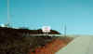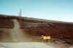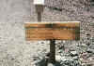
0.8 (16.8) Pahoehoe flow with olivine crystals; age about 1500 years; this flow is beheaded by the summit caldera.
1.0 (16.6) White line in the center of the road starts (ends). Drive with headlights on straddling the line. Keep a sharp lookout for oncoming vehicles.
4.4 (13.2) Collapsed lava tube at the downslope side of the road.
5.7 (11.9) Lava tube and "bonbons" on 200 year old flow, on the downslope side of the road.
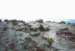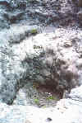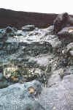
6.6 (11.0) Red Cinder Cone road on the uphill side of the road. The red paving material on the MLO road comes from this cone. Helicopter landing site is across from from road juncture.
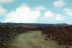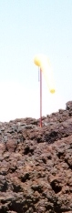
6.7 (10.9) Lava tube with several cave-in's on the downslope side of the road.
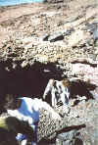
8.3 (9.3) Older brown colored lava with vegetation surrounded by newer, blacker 1855 lava without vegetation.
9.1 (8.5) Kulani Mauka corner. MLO rain gauges and temperature shelter on downslope side and Hawaiian Telephone and TV station microwave transmitters in front (back), and a large collapsed lava tube 100 ft. uphill from the corner. The tube may be entered on foot. Note the moss growing inside the east wall which obtains moisture from clouds flowing uphill through the tube.
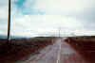
10.1 (7.5) The road was once painted silver here but is now repainted flat black. This is the site of a Renault car commercial starring an essentially naked "Mercury" running up the mountain. This is also the area for the filming of a Honda Accord commercial and a Playboy "Playmates of Hawaii" photo shoot.
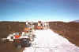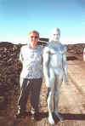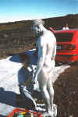
10.7 (6.9) Cinder cone road on left (right).
11.5 (6.2) Memorial to a motorbike racer who was killed on the spot, May 1994, during a Mauna Loa to Mauna Kea race.
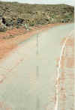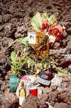
13.5 (4.1) Mauna Loa Road turns sharp to right (left). Gravel road to the west was intended to go to Kona but was never completed; the councilman supporting the project lost a subsequent election.
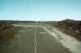
14.8 (2.8) BLIND TURN!
15.4 (2.2) Outline of Charles de Gaulle’s profile on the horizon produced by lava features, look back on the left or (front right).
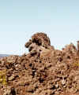
17.5 (.1) Puu Huluhulu (shaggy or hairy hill) Natural Tree And Hawaiian Bird Sanctuary, about 200 ft high with a summit elevation of 6758 ft. The hill is of Mauna Kea composition and is 10,000 - 20,000 years old. The cinder cone is surrounded by a 2000 year old and a 1935 lava flow . The hill is fenced to protect the plants and birds from goats and other wild animals.
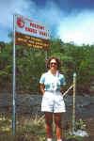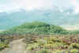
17.6 (0) Mauna Loa Road and Saddle road junction.

OTHER THINGS TO WATCH FOR:
The different colors of the lava flows; generally the blacker the lava flow the newer it is.
Different plants at different elevations.
Ohelo berry plants (plant on right in picture) at the lower elevations. Be careful not to eat the poisonous berries (plant on the left) which look like Ohelo berries. The ancient Hawaiians used the berries as an execution tool for criminals. Better yet, do not eat any berries!
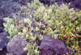
Wild animals such as goats, Mouflon sheep, wild pigs, rare Hawaiian birds, pheasants, the Hawaiian Nene goose, quail and wild turkey.
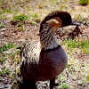
The occasional marijuana grower.
In summer months there are jet fighters flying overhead and bombing at the range at the top of the Saddle Road.
Some telephone poles at higher elevations are splintered from lightning strikes. The lightning vaporizes moisture in the poles which expands and blows off a strip of the north side of the poles. Only the north sides of the poles are moist from the afternoon upslope clouds.
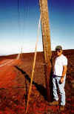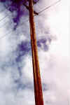
Look out for on coming cars, hikers, and bike riders coasting down the road.

